**IoT Enabled Real Time Traffic Management System**

***Abstract***

*In this current generation of emerging technologies, data plays a vital role in every field of work. Despite tremendous advancements still the signals are being controlled manually by personnel in the hub. Especially in downtown areas, people face traffic congestion. This paper proposes an IoT based traffic management solution to enhance traffic-related issues and to guide the ambulance driver to find the signal status and to choose the path where traffic flow can be manipulated and traffic violations can be identified by onsite traffic officers and controlled over the internet. It depicts a framework where a couple of sensors like IR sensor and RFID interfaced with node MCU to work based on the principles of IoT. By deploying it normal cities can be transformed into smart cities by exploiting ICT. The paradigm of IoT can play a vital role in automating things. Moreover a technique of measuring the traffic density is also considered for the smooth movement of vehicles. The scheme proposed is more general and can be implemented in any metropolitan city with greater ease.*

***Keywords:*** *Internet of Things (IoT), Information and Communication Technology (ICT), IR Sensor, RFID, MCU.*

# Introduction

Intelligent traffic monitoring plays a crucial role in urban traffic and modern transportation. The total number of registered motor vehicles with the government reached approx. 230 million in March 2016. Indian traffic and transport system has several drawbacks which causes problems of delays, unsafety, pollution, and inadequate parking [1]. The major problem with increasing congestion affects directly the ambulance drivers whose vital job is to drive the patients to the destination hospital at the right time although the congestion is high which is usual in developing cities. While driving any common rider would see the ambulance stuck in traffic but they would be helpless at the point due to the traffic.

The human population in the urban regions all over the world has drastically grown, surpassing the corresponding value in the rural areas. Fig.1 shows the graph of the population comparing rural and urban areas [3]. From the figure, it is evident that the population is going to increase steeply in the coming years to the number of vehicles on the road. The demand for transportation also increases with the increasing population. The conventional traffic management system is inefficient with the use of traffic lights and manual police control. This in turn leads to heavy traffic problems and as a result vehicle emissions increases and consume our precious time.

*Corresponding Author



Fig.1 Population Graph

Brussels, the capital city of Belgium, stands at the top of the list of most traffic affected cities in the world, as reported by Forbes [2]. Traffic Monitoring Signal timing has been deployed by using multiple features of components in IoT. Traffic is optimized by implementing an IoT platform for efficiently allocating varying time to all traffic signals according to available vehicles count in road path [12]. TMS will helpful to client users to know timing arability and traffic flow count in any area of their nearby locality of any regions [4]. The traffic light management is the development of a smart traffic management system based on the internet of Things (IoT) and developed to support the decision making of traffic officers. The system can detect the congestion level of every road at the intersection based on the density of cars with the facilitate of RFID technology [5].

The framework gives data about street blockage, capacity to control the stream of activity, and furthermore practice crisis exit for crisis vehicle. Interfacing of the Internet with the genuine existing movement instrument additional items the capacity of the proposed framework to lessen human intercession and increment the nature of activity administration [6]. The system can predict probable traffic congestion at the intersection point. A block that uses the concept of internet of things with a cluster of consoles into a single technology so that it handles effective communication among a large number of heterogeneous highly distributed, and decentralized devices within the IoT [9], wireless sensor technologies, object ad-hoc networking, and Internet-based information systems in which tagged traffic objects can be automatically represented, tracked, and queried over a network [8].In the existing traffic management system, traffic lights with predefined timers are used, along with manual control. Without considering the real-time traffic data, at the instance it can happen that a green light is seen in the traffic light in an empty road whereas red light in a dense road is because the same time interval of green lights is granted to every lane [7].

The increasing number of cars on streets is not the prime reason for the traffic problems to occur; there is a lack of deliberate planning to deal with this amount of vehicles that are floating in the streets [10]. For example, it is a common sight for the riders to notice some vehicles waiting for the signal through the lane is empty. This might collapse the traffic, which would require manual supervision. The problem of traffic particularly in cities is not an easy problem to address and solve. So in that case it is important to improve the public transportation system and provide people with means to be less dependent on their car [11]. In addition, it is also necessary to enhance other possibilities of transportation, to improve safety on the streets, to increase people security and walkability through the

streets. This substitute would hardly be accepted, which initiates the need for an efficient traffic management system to overcome the problems of the existing system [13][14].

# Materials and Methods

### Methodology

In order to provide an efficient solution to the existing system, the traffic management system was designed. The first and primary element of this system is the wireless sensor nodes consisting of sensors. The sensors interact with the physical environment means vehicle presence or absence while the local server sends the sensors data to the central microcontroller. Fig.2 explains the complete flow of the system’s operation.



CONTROL ROOM

ESP-8266

MONITOR

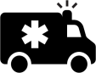



RFID SENSOR

IR SENSOR



TRAFFIC LIGHT

Fig.2 Block Diagram of Traffic Management System

MOBILE

The methodology is proposed with the main aim to felicitate way to the ambulance vehicles. In the proposed method the traffic lights are altered based on the congestion in the road. The vehicles are fitted with sensors to monitor the movement in a particular lane. But in the manual mode as in Fig.3, the traffic is controlled by authorized persons in the control room. whereas in the proposed method ESP8266 acts as a microcontroller is used in the system takes control of all. As far as the microcontroller is concerned it cannot handle all the sensors at once for which microprocessors like raspberry pi can be used in place of a microcontroller.

CONTROLLER

CAMERA

Fig.3 Manual Mode of Tracking



In the proposed method ESP8266 acts as a microcontroller is used in the system takes control of all. As far as the microcontroller is concerned it cannot handle all the sensors at once for which microprocessors like raspberry pi can be used in place of a microcontroller. The fig.4 represents the flow of the sensors and traffic lights if the RFID sensor detects the ambulance in any lane and checks for the density of the vehicles and according to that the lanes are opened but preference is given to ambulance and any emergency vehicles like fire engines etc fitted with the RFID’s..



RFID AND

IR SENSOR

Restores

the traffic signal

If

ambulance is detected



RED signal changes to Green

Fig.4 Working Process for Emergency Vehicles



Less traffic

### Hardware Description

* + 1. **Node-MCU :**

The ESP8266 is a low-cost Wi-FI microchip with microcontroller capability. It’s very low price and the fact that there were very few external components on the module, which suggested that it could eventually be very inexpensive in volume. ESP8266 can be used as an external Wi-Fi module, which uses the standard AT Command firmware by connecting it to any microcontroller using many serial ports such as UART.

### RFID :

RFID or Radio Frequency Identification system consists of two main components, a transponder/tag attached to an object to be identified, and a Transceiver also known as interrogator/Reader. A Reader consists of a Radio Frequency module and an antenna which generates a high-frequency electromagnetic field. RFID are of two types active and passive. In our proposed system we have used passive tag. Passive tags will not have the power supply whereas the active tag will have.

### IR Sensor :

An infrared sensor circuit is the basic and popular sensor modules in many of the [electronic device](https://www.elprocus.com/basic-components-used-electronics-electrical/)s. This sensor is similar to human vision, which is used to detect obstacles and it is one of the most common applications for real-time implementation. An IR sensor measures the heat of an object and also detects the motion. These types of sensors are used to measure only infrared radiation, rather than emitting it that is called a [passive IR sensor.](https://www.elprocus.com/passive-infrared-pir-sensor-with-applications/)

### Ultrasonic Sensor :

An ultrasonic sensor is an instrument that measures the distance to an object by emitting and receiving ultrasonic sound waves. An ultrasonic sensor uses a transducer in it to send and receive ultrasonic pulses that returns the object's proximity to the controller.

### LED :

It’s a forward-biased p-n junction diode that emits light when energized. It used in the traffic light for identification for the riders in the road due to its long-range visibility.

### Recursive Algorithm

Algorithm used to track the vehicle count and manipulate traffic and flow regarding the same is shown in the fig.5

No. of sensors = 8 and are denoted by S1, S2, S3, S4, S5, S6, S7, S8 No. of cars in Lane 1 (N1) = S1-S2

No. of cars in Lane 2 (N2) = S3-S4 No. of cars in Lane 3 (N3) = S5-S6 No. of cars in Lane 4 (N4) = S7-S8

L = (L1, L2, L3, L4), N = (N1, N2, N3, N4), T = (T1, T2, T3, T4)

Step 1: Start

Step 2: Sensors will read the no. of vehicles on each lane (i.e. L1, L2, L3, L4)

Step 3: If (Vehicle Count < Threshold), then status = Normal traffic. Turn on thegreen signal for all the lanes one after another in a sequential manner (L1-L2-L3-L4). When signal is green for one lane, the others will remain red.

Step 4: else status = congestion.

Step 5: COMPARE (N1, N2 , N3, N4), Select the highest of the four (say N),turn on green signal for that lane (say L) for time (T). When time T ends, turn on the red signal.

Step 6: COMPARE (N2, N3, N4), Select the highest of the three (say N), turn on green signal for that lane (say L) for time (T). When time T ends, turn on the red signal.

Step 7: COMPARE (N3, N4), Select the highest of the two (say N), turn on green signal for that lane (say L) for time (T). When time T ends, turn on the red signal.

Step 8: The last remaining lane automatically gets selected and it is given the green signal for time T.

Step 9:Jump to Step 3.



START

Count Number of Vehicles



Is count < threshold

NO

YES

If more lanes are there

NO

Open Signal in Sequence

Remove Current Lane from Comparison

Open the Lane with Highest Number

Compare Numbers in Each Lane

Status=Congestion

NormalTraffic

Compare Count with Threshold

Vehicle Count++

YES

Fig. 5 Flowchart for monitoring traffic congestion

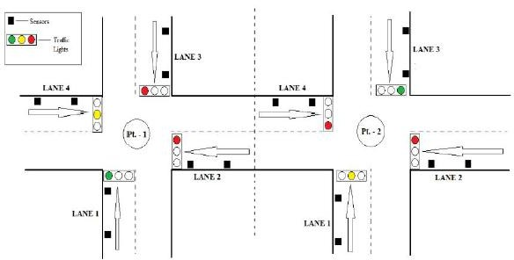

LANE-3

LANE-3

LANE-4

Pt-1

Pt-2

LANE-2

LANE-1

LANE-1

LANE-2

LANE-4

Sensor s

Traffic Lights

Fig. 6 Lane Representation

In fig.6 at pt-1, lane 1 is currently open with green signal and lane 4 is ready with yellow signal but lane 2 and lane 3 are blocked. In lane 3, vehicle count is higher than the threshold value, so the lane 3 of pt 1 is blocked in the pt 2. Thus re-routing them through another lane.

Pt-1

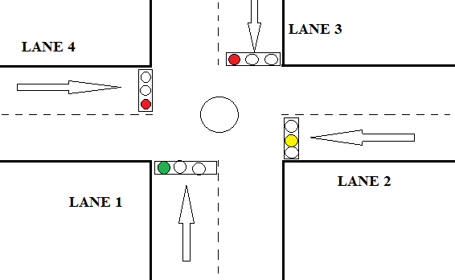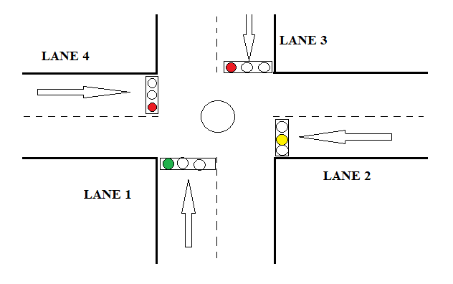

Pt-1

Fig.7 Lane at point 1

In the above Fig. 7, Lane 1 is open with a green signal and other lanes are closed with a red signal. In next sequence lane 2 would be open with green signal and other lanes are closed with a red signal, and lane 3 will be opened with green signal and other lanes are closed with red signal and after that Lane 4 will get the green signal automatically.

# Results and Discussion

In the proposed system all the ambulance are fitted with RFID tag and all the lanes will be fitted with the RFID reader, IR Sensors which are all connected the controller. So, when the ambulance is detected, it is given preference and the lanes are cleared and the signal is made open to the ambulance vehicle to pass as seen in fig 9 and fig 10. In the meantime all other signals are closed until the ambulance moves away. This detection is made by using RFID tag and reader which communicates with the controller to alter the traffic lights accordingly.

IR sensors are fitted all along the lane to check the passage of vehicles at a particular interval, to provide hassle-free commute to the riders. It checks for movement and if it finds no movement and it communicates with other IR sensors are if its count is less than other then it communicates with controller and lane with less movement is closed while the other lane is made to open. In this particular way serial communication between the sensors is established using master-slave concept.

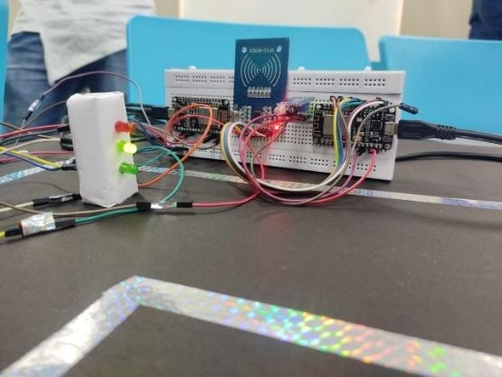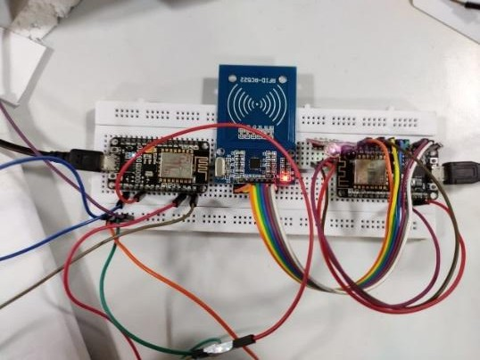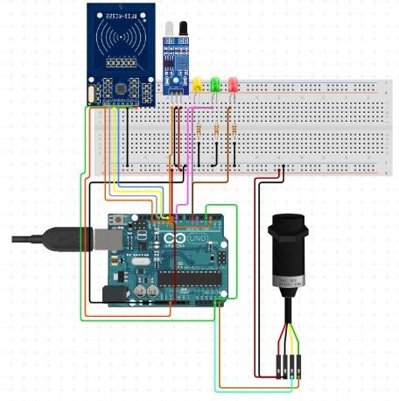

## Fig.8 Experimental Setup of IoT enabled Traffic Management System

To enhance the mobility of the vehicles and ease the work of the personnel a mobile application is developed as seen in fig.8 which can be accessed only by the respective authorities. It can control the signals remotely and notify based on the output obtained from the sensors which can be accessed from anywhere in the world.

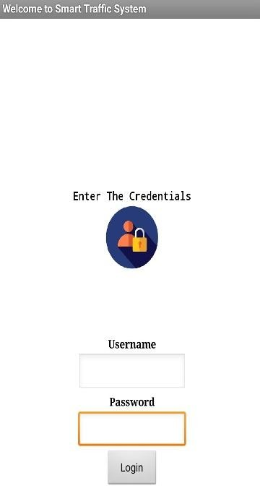 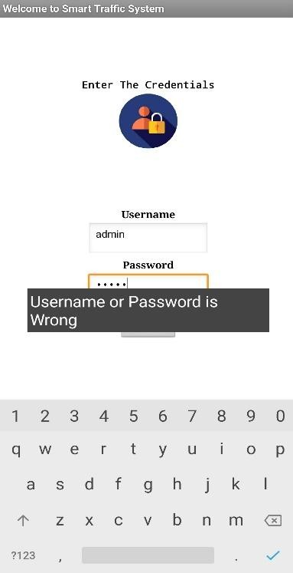 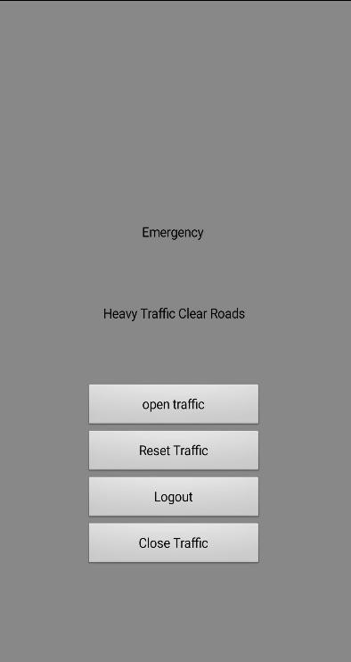

(a) (b) (c)

Fig.9 Mobile Application for Controlling Traffic

It is clear from the above picture that credentials are required to access the application if any credentials are not correct error message is popped up saying that username or password is wrong as in fig 9 (b). In fig 9 (c) controls appear for the authority and notifications are displayed based on the density of the lane.

# Conclusion

The proposed system was experimentally setup and the expected results were achieved. The major advantage over the existing system includes the minimized number of accidents, reduced fuel consumption and saves time, remotely controllable, and minimizes hassle and cost of commuting. The optimized approach makes the system efficient. The proposed method would be helpful for the authorities to enhance the existing system. Further this system can be extended with an accident message alert system and the entire system can be applied to multiple layer security for data generated, also the mobile application developed can be customized furthermore with more controls.